MemCache

in-memory cache

multithreading

Redis

in-memory cache

single threading + multicomplexing

(Single Thread I/O Multiplex)

multicomplex:

- take many threads and share a single connection.

- letting the client library take communication from those threads and intelligently merge it into a single connection.

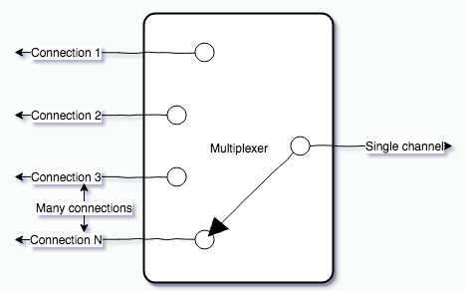

- When using a multiplexer, all commands are pressed into the same connection at all times, so unrelated threads with unrelated Redis commands are sent immediately to the server, no waiting for a connection from the pool to be available or any responses to come back